# **DBT JOBS - PERFORMANCE MONITORING**

Monitoring DBT job performance through Snowsight dashboards provides valuable insights into the efficiency and effectiveness of your data transformation processes. With Snowsight, you can track and analyze key performance metrics in real-time. You can easily identify bottlenecks, inefficiencies, or resource-intensive processes that may impact overall job performance. By leveraging Snowsight's data visualization capabilities, you can create customized metrics and visualizations specific to DBT job performance. This enables you to track trends, compare performance across different time periods or job types, and identify areas for improvement. Snowsight dashboards can be shared with stakeholders, promoting collaboration and facilitating a shared understanding of job performance.

Below KPIs on DBT job performance enables teams to work together to identify and address performance bottlenecks, resulting in improved data transformation processes.

## Total Job count :

select count(*) from jobs_list_atm;



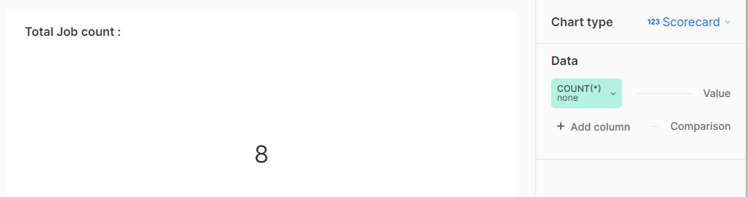

## Total Runs :

select count(*) from runs_list_atm;



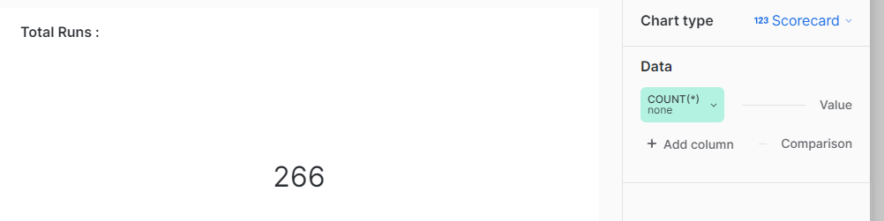

## Job Schedule Status :

select job_name, CASE

WHEN job_schedule=True THEN 'Active'

WHEN job_schedule=False THEN 'Inactive'

END AS schedule_status from jobs_list_atm group by schedule_status, job_name;



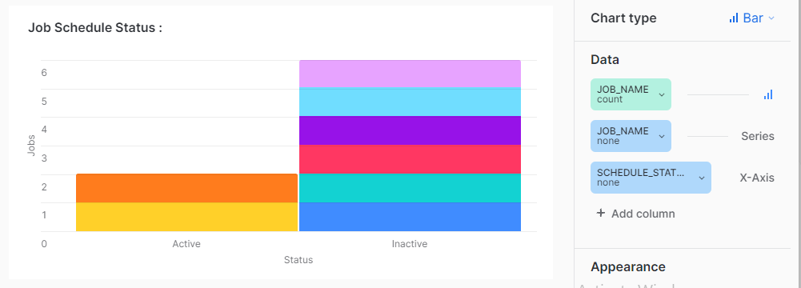

## Runs Execution Status :

SELECT status, COUNT(*) AS run_count

FROM runs_list_atm

GROUP BY status;



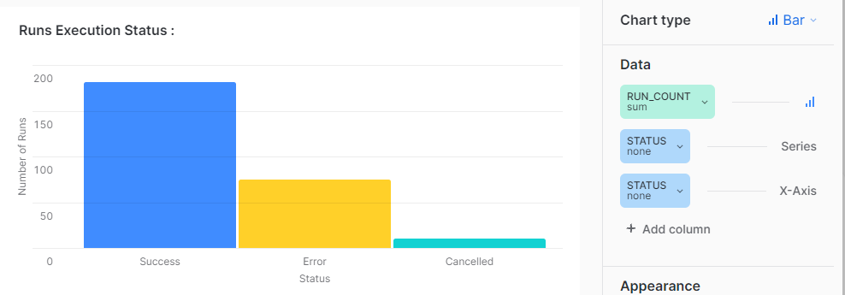

## Run Duration Trend :

SELECT run_id, started_at,

EXTRACT(HOUR FROM run_duration) * 3600

+ EXTRACT(MINUTE FROM run_duration) * 60

+ EXTRACT(SECOND FROM run_duration) AS total_seconds

FROM runs_list

where status= 'Success'



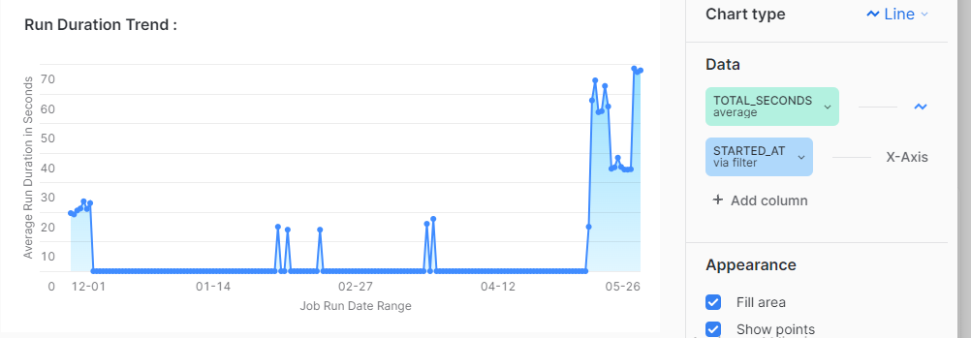

## 

## Queue duration per Job :

SELECT job_name, status, round(AVG(

EXTRACT(HOUR FROM queued_duration) * 60 -- Number of seconds in an hour

+ EXTRACT(MINUTE FROM queued_duration) * 1-- Number of seconds in a minute

+ EXTRACT(SECOND FROM queued_duration) / 60 ),2) AS avg_queued_duration

FROM runs_list_atm r join jobs_list_atm j on r.job_id = j.job_id

GROUP BY job_name, status order by avg_queued_duration desc,job_name desc;



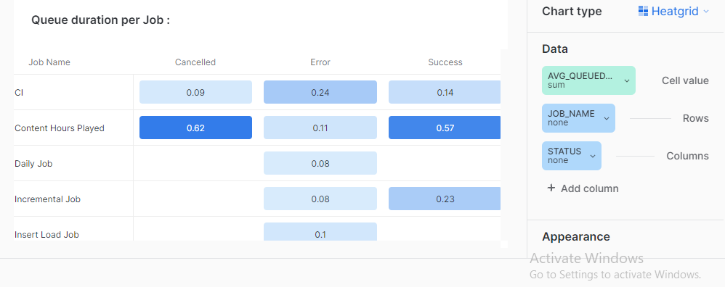

## Run Duration of top 7 Unsuccessful Runs:

SELECT run_id, status, job_id, 20 as timeout_limit,

EXTRACT(HOUR FROM run_duration) * 60 -- Number of seconds in an hour

+ EXTRACT(MINUTE FROM run_duration) * 1-- Number of seconds in a minute

+ EXTRACT(SECOND FROM run_duration) / 60 AS total_run_duration

,(case when total_run_duration<20 then 'RUN DURATION'

else 'TIMEOUT LIMIT REACHED' end )as category

FROM runs_list_atm

ORDER BY run_duration DESC

LIMIT 7;



